PROJECT REPORT TEMPLATE

1. **INTRODUCTION**
   1. **OVERVIEW**

**BOOK COVER USING CANVA**

The “Crafting Compelling Book Covers with Canva” project focuses on designing captivating and professional book covers using Canva A well –designed book cover not only grabs a reader’s attention but also conveys the essence of the book’s content and style, ultimately contributing to its marketability and success.

* 1. **PURPOSE**

To draw the attention of the potential readers away from all those other tomes and novellas and sell them on the idea that the page-turner is the next book they need on their nightstand.

1. **PROBLEM DEFINITION & DESIGN THINIKING**

**2.1 EMPATHY MAP**

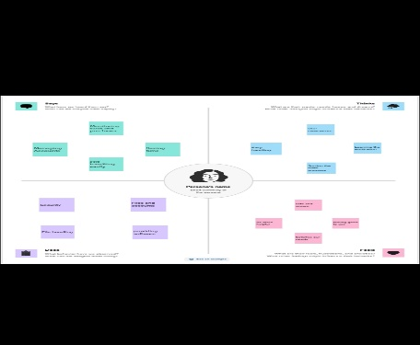

**2.2 IDEATION & BRAINSTORMING MAP**

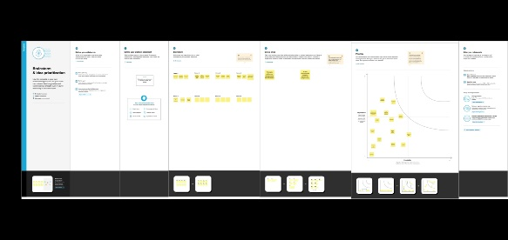

**3.RESULT**



**4. ADVANTAGES & DISADVANTAGES**

**ADVANTAGE:**

It catches the potential reader’s attention and helps them instantly know if the book is for them. A strong design appeals to feelings and emotions, possessing the ability to intrigue and attract readers.

**DISADVANTAGES:**

Too many elements on the cover. This is an all too common mistake, particularly with inexperienced designer. Poor or wrong font choices, and poor image quality.

**5. APPLICATIONS**

As a physical component of the book, the cover is a skin, a membrane, and a safeguard. The book cover is used to attract the readers to read the book when they come to library to read the book or buy the book.

**6. CONCLUSION**

Through using CANVA and creating the project we learnt many creative things and it develops innovative thoughts in us. We came to know as many different templates and how to select the color combinations. And we came to know about the variety of animations and graphics.